

Europass  Curriculum Vitae |  | 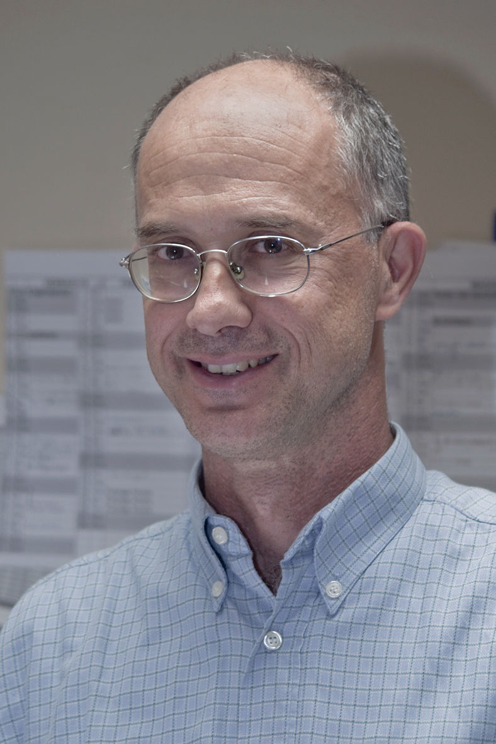
Personal information
First name(s) / Surname(s) |  | Giovanni Lamura
Address(es) |  | Via Frediani 9, 60100 Ancona, Italy
Telephone(s) |  | +39-071-8004797 |  |  |  |  | Mobile: |  |  |  | 0039-339-8013837
Fax(es) |  | +39-071-35941
E-mail |  | g.lamura@inrca.it
Nationality |  | Italian
Date of birth |  | 2nd May 1963
Gender |  | Male
Occupational field |  | Gerontological research
Work experience
Dates |  | 20th July 1992 – today
Occupation or position held |  | Senior researcher
Main activities and responsibilities |  | Head of Centre for Socio-Economic Research on Ageing (since September 2013)
Name and address of employer |  | I.N.R.C.A. (Italian National Research Centre on Ageing), Via S. Margherita 5, 60124 Ancona, Italy
Type of business or sector |  | Public elder care provider and research institute on ageing-related issues
Dates |  | 1st March – 31st August 2011
Occupation or position held |  | Director of the Health and Care Department (seconded from I.N.R.C.A.)
Main activities and responsibilities |  | Supervision of research carried out within the department indicated above
Name and address of employer |  | European Centre for Social Welfare Policy and Research, Vienna, Austria
Type of business or sector |  | UN-affiliated policy and research centre
Dates |  | 1st September 2010 – 28th February 2011
Occupation or position held |  | Researcher within the Health and Care Department (seconded from I.N.R.C.A.)
Main activities and responsibilities |  | Research on long term care, migrant work in elder care and ICT in informal caregiving
Name and address of employer |  | European Centre for Social Welfare Policy and Research, Vienna, Austria
Type of business or sector |  | UN-affiliated policy and research centre
Dates |  | 1st August 2006 – 5th September 2007
Occupation or position held |  | Visiting scholar
Main activities and responsibilities |  | In-depth analysis of the data collected by the EUROFAMCARE study on support services for family carers of older people in Europe
Name and address of employer |  | Social Gerontology Centre, Dept. of Medical Sociology, University Medical Centre Hamburg-Eppendorf, Martinistr. 52, 20246 Hamburg, Germany
Type of business or sector |  | Public hospital and research centre
Education and training
Dates |  | November 1982 – February 1990
Title of qualification awarded |  | Degree in Economics
Principal subjects/occupational skills covered |  | Micro- and macro-economics; sociology; accounting; civil and commercial law
Name and type of organisation providing education and training |  | University of Ancona (Italy)
Dates |  | November 1990 – August 1994
Title of qualification awarded |  | Ph.D. in “Life Course and Social Policy” (Ph.D.-thesis on “Migration and municipal integration policies: a comparison Bremen-Bologna”)
Principal subjects/occupational skills covered |  | Social policy¸ migration policies, longitudinal data analysis, qualitative research
Name and type of organisation providing education and training |  | University of Bremen (Germany)
Personal skills and competences
Mother tongue(s) |  | Italian
Other language(s)
Self-assessment |  |  | Understanding |  |  |  |  | Speaking |  |  |  |  | Writing
European level (*) |  |  | Listening |  | Reading |  |  | Spoken interaction |  | Spoken production
English |  |  | C1 | Proficient user | C2 | Proficient user |  | B1 | Independent user | B1 |  | Independent user | B2 | Independent user
German |  |  | C1 | Proficient user | C2 | Proficient user |  | B1 | Independent user | B1 |  | Independent user | B1 | Independent user
French |  |  | A2 | Basic user | A2 | Basic user |  | A1 | Basic user | A1 |  | Basic user | A1 | Basic user
 |  | (*) Common European Framework of Reference for Languages

Date: 1st July 2016 Signature:
Selection of international research projects carried out in the last 10 years (amount of coordinated funds: over 2,0 million Euros)

- 2016-2018: European Network on Long-Term Care Quality and Cost Effectiveness and Dependency Prevention (EU Directorate of Employment, Social Affairs and Inclusion)
- 2013-2016: MOPACT - Mobilising the potential of active ageing in Europe (FP7)
- 2012-2015: INNOVAGE - Social Innovation for Active and Healthy Ageing (FP7)
- 2012-2013: AIDA: Advancing Integration for a Dignified Ageing. Fostering the integration of social and health services in LTC (Progress)
- 2010-2011: CARICT: ICT-based solutions for informal caregivers - Assessing their impact on the sustainability of long-term care in an ageing Europe (IPTS) (overall project coordinator)
- 2009-2011: FUTURAGE: A Definitive Roadmap for Ageing Research in Europe (FP7)
- 2009-2010: “Carers@work”: Reconciliation of employment and eldercare - Strategies for sustainable potential of care and productivity in ageing societies: a European comparison (Volkswagen Foundation)
- 2008-2011: PHASE: Public Health Impact of Interpersonal Violence (European Agency for Health and Consumers)
- 2008-2011: ASPA: Activating Senior Potential in an Ageing Europe (FP7)
- 2008-2010: ABUEL: Elder Abuse: A Multinational Prevalence Study (European Agency for Health and Consumers)
- 2007-2010: EURHOMAP: Mapping Professional Home Care in Europe (European Agency for Health and Consumers)
- 2005-2007: Employment strategies for an Ageing Workforce (European Foundation for the Improvement of Living and Working Conditions)
- 2003-2006: PEFETE: Pan-European Forum for Education of the Elderly (Grundtvig Programme)
- 2003-2005: EUROFAMCARE: supporting family carers of older people in Europe: characteristics, coverage and usage (FP5)
- 2003-2004: CEIL: Contributing to Equality from Independent Living (EU Directorate of General Employment and Social Affairs)
- 2003-2004 Labour Supply in Care Services (European Foundation for the Improvement of Living and Working Conditions)
- 2003-2004: OTWL: Organisation of Time throughout the Working Life (Europ. Foundation for the Improvement of Working & Living Conditions)
- 2002-2004: ESAW: Ageing Well - A European Study of Adult Well-being (FP5)
____________________________________________________________________________________________________________________

Currently member of following research networks:
- COST Action 1402 – Ageism from a Multi-national, Interdisciplinary Perspective (http://www.cost.eu/COST_Actions/isch/IS1402)
- ACROSSING: Advanced TeChnologies and PlatfoRm fOr Smarter ASsisted LivING http://www.acrossing-itn.eu/
- ROSEnet: Reducing Old-Age Social Exclusion: Collaborations in Research and Policy (coordinator: Kieran Walsh, Galway University).

Selected recent publications in English:
Zaidi A., Harper S., Howse K., Perek-Bialas J., Lamura G. (eds.) Building Evidence for Active Ageing Policies: Active Ageing Index and its Potential. UNECE, Geneva (in press).
Melchiorre M.G., Di Rosa M., Lamura G. et al. (2016) Abuse of older men in seven European countries: A multilevel approach in the framework of an ecological model. PLoSONE, 11, 1, Article number e0146425.
Santini S., Andersson G., Lamura G. (2016) Impact of incontinence on the quality of life of caregivers of older persons with incontinence: A qualitative study in four European countries. Archives of Gerontology and Geriatrics, 63, pp. 92-101.
Barbabella, F., Chiatti, C., Di Rosa, M., Lamura, G., Martin-Matthews, A., Papa, R., & Svensson, T. (2016) Launching an interdisciplinary “International Summer School on Ageing” (ISSA): Aims, methodology and outcomes. Educational Gerontology, 42, 4, 253-264.
Barbabella, F., Chiatti, C., Rimland, J.M., Melchiorre, M.G., Lamura, G., et al (2016). Socioeconomic predictors of the employment of migrant care workers by Italian families assisting older Alzheimer’s disease patients: Evidence from the Up-Tech study. Journal of Gerontology, Social Sciences, 71, (3), 514-525, doi:10.1093/geronb/gbv045.
Di Rosa M. and Lamura G. (2016) The impact of incontinence management on informal caregivers’ quality of life. Aging Clin Exp Res, 28, (1), 89-97, DOI 10.1007/s40520-015-0367-7.
Principi, A., Schippers, J., Naegele, G., Di Rosa, M., Lamura, G. (2016) Understanding the link between older volunteers’ resources and motivation to volunteer. Educational Gerontology, 42 (2), 144-158.
Principi P., Fabietti P., Lamura G. (2015),"Perceived qualities of older workers and age management in companies", Personnel Review, 44 (5), 801 – 820.
Lüscher K., Hoff A., Lamura G., Renzi M., Sánchez M., Viry G., Widmer E., Klimczuk E., de Salles Oliveira P. (2015) Generations, intergenerational relationships, generational policy. A multilingual compendium. University of Konstanz, Germany.
Barbabella F., Di Rosa M., Melchiorre M.G. and Lamura G. (2015) The Employment of Migrant Workers in Italy’s Elder Care: Opportunities and Challenges. In Karl U. and Torres S. (eds.) Ageing in Contexts of Migration. Routledge, 159-172.
Lamura G., Chiatti C., Barbabella F. & Di Rosa M. (2014) Filling the gap in long-term professional care through systematic migration policies. Synthesis report. Luxembourg: Publications Office of the European Union (http://ec.europa.eu/social/BlobServlet?docId=11116&langId=en).
Melchiorre M.G., Penhale B. & Lamura G. (2014): Understanding Elder Abuse in Italy: Perception and Prevalence, Types and Risk Fac ors From a Review of the Literature, Educational Gerontology, DOI: 10.1080/03601277.2014.912839 (http://www.tandfonline.com/doi/pdf/10.1080/03601277.2014.912839)
Principi, A., Jensen, P. H. and Lamura, G. (eds.) (2014) Active Ageing: Voluntary Work by Older People in Europe, Bristol, The Policy Press (http://www.policypress.co.uk/display.asp?k=9781447307204).
Lamura G., Chiatti C., Barbabella F. & Di Rosa M. (2013) Migrant long-term care work in the European Union: Opportunities, challenges and main policy options. EU-Peer Review on ”Filling the gap in long-term professional care through systematic migration policies”. Vienna, ÖSB Consulting (http://ec.europa.eu/social/BlobServlet?docId=11116&langId=en)
Principi A., Lamura G., Sirolla C., Mestheneos L., Bień B., Brown J., Krevers B., Melchiorre M.G., Döhner H. on behalf of the EUROFAMCARE research group (2013) Work restrictions experienced by midlife family caregivers of older people: empirical evidences from six European countries. Ageing and Society, 34 (2), 209-231.
Melchiorre MG, Chiatti C, Lamura G, Torres-Gonzales F, Stankunas M, et al. (2013) Social Support, Socio-Economic Status, Health and Abuse among Older People in Seven European Countries. PLoS ONE 8(1): e54856. doi:10.1371/journal.pone.0054856.
Bień B., McKee K., Kofahl C., Triantafillou J., Lamura G., Doroszkiewicz H., Krevers B., Döhner H. (2013) Disabled older people’s use of health and social care services and their unmet care needs in six European countries. International Journal of Public Health, 1-7, doi: 10.1007/s00038-012-0388-3.
Chiatti C., Di Rosa M., Melchiorre M.G., Manzoli L., Rimland J.M and Lamura G. (2013) Migrant care workers as protective factor against caregiver burden: results from a longitudinal analysis of the EUROFAMCARE study in Italy, Aging & Mental Health (http://dx.doi.org/10.1080/13607863.2013.765830).
Chiatti, C., Di Rosa, M., Barbabella, F., Greco, C., Melchiorre, M.G:, Principi, A., Santini, S., Lamura, G. (2013) Migrant care work for elderly households: trends and developments in Italy on the background of global developments. In J. Troisi and von Kondratowitz H-J. (eds.) Ageing in the Mediterranean. Bristol, Policy Press, 235-257.
Chiatti C., Melchiorre M.G., Di Rosa M., Principi A., Santini S., Döhner H. and Lamura G. (2013) Family networks and supports in older age. In Phellas C. (ed.) Aging in European Societies. Healthy ageing in Europe. New York, Springer, 133-150.
Rodrigues R., Huber M. and Lamura G. (eds.) (2012) Facts and Figures on Healthy Ageing and Long-Term Care in Europe and North America. European Centre for Social Welfare Policy and Research, Vienna (http://www.euro.centre.org/data/LTC_Final.pdf).
Carretero, S., Stewart, J., Centeno, C., Barbabella, F., Schmidt, A., Lamontagne-Godwin, F., & Lamura, G. (2012). Can technology-based services support long-term care challenges in home care? Luxembourg: Publications Office of the European Union.
Principi, A., Chiatti C., Frerich, F., Lamura, G. (2012) The Engagement of older people in civil society organizations. Educational Gerontology, 38(2), 83-106.
Di Rosa M., Melchiorre M.G., Lucchetti M. & Lamura G. (2012) The impact of migrant work in the elder care sector: recent trends and empirical evidence in Italy. European Journal of Social Work, 15 (1), 9-27 (http://www.tandfonline.com/doi/abs/10.1080/13691457.2011.562034).
Chiatti C., Barbabella F., Sinigaglia A., Thornton M. and Lamura G. (2011) Inclusion and participation in the community and the labour market. In: Walker A. (ed.) The future of ageing research in Europe: a Road Map. Sheffield, University of Sheffield, pp. 38-49 (http://futurage.group.shef.ac.uk/assets/files/Final%20road%20map/FUTURAGE%20A%20Road%20Map%20for%20European%20Ageing%20Research%20-%20October%202011.pdf ).
Chiatti C., Barbabella F. and Lamura G. (2011) Guaranteeing the quality and sustainability of social protection systems. In: Walker A. (ed.) The future of ageing research in Europe: a Road Map. Sheffield, University of Sheffield, pp. 50-57 (http://futurage.group.shef.ac.uk/assets/files/Final%20road%20map/FUTURAGE%20A%20Road%20Map%20for%20European%20Ageing%20Research%20-%20October%202011.pdf ).
Santini S., Principi A., Renzi M., Lamura G. (2011) Carers@Work - Carers between Work and Care: Conflict or Chance? The Italian National Report. INRCA, Ancona (http://www.carersatwork.tu-dortmund.de/download/National%20report%20Italy.pdf)
van der Veen R., Versteeg M., Mak S., Bodnarova B., Selestiakova K., Hanson E., Andersson G., Santini S., Quattrini S., Lamura G. (2011) Quality of life of carers managing incontinence in Europe. Eurocarers, Dublin (http://www.eurocarers.org/userfiles/file/Carers%20managing%20incontinenceFinal5%2011.pdf).
Soares J.J.F., Barros H., Torres-Gonzales F., Ioannidi-Kapolou E., Lamura J., Lindert J., de Dios Luna J., Macassa G., Melchiorre M.G., Stankunas M. (2010) Abuse and Health Among Elderly in Europe. Lithuanian University of Health Sciences Press, Kaunas. http://www.hig.se/download/18.3984f2ed12e6a7b4c3580003555/ABUEL.pdf
Lamura G., Chiatti C., Di Rosa M., Melchiorre M.G., Barbabella F., Greco C., Principi A., Santini S. (2010) Migrant workers in the long-term care sector: lessons from Italy. Health and Ageing, 22, 8-12.
Lamura G., Melchiorre M.G., Principi A., Lucchetti M. (2009) Migrant workers in the eldercare sector: the Italian experience. Retraite et Société, Selection 2008. Caisse Nationale d’Assurance Vieillesse, Paris, 125-152.
Tomassini C., Lamura G. (2009) Population ageing in Italy and Southern Europe. In: Uhlenberg P. (ed.) International Handbook of Population Aging. Springer, Dordrecht, 69-89.
Lamura G., Mnich E., Nolan M., Wojszel B., Krevers B., Mestheneos L. and Döhner H. on behalf of the EUROFAMCARE group (2008) Usage and accessibility of support services for family carers of older people in six European countries: prevalence findings from the EUROFAMCARE study. The Gerontologist, 48(6), 752-771.
Lamura G., Döhner H., Kofahl C. on behalf of the EUROFAMCARE Consortium (2008) Services for Supporting Family Carers of Older People in Europe: Characteristics, Coverage and Usage. A Six-Country Comparative Study. Lit Verlag, Hamburg.
Askham J., Ferring D., Lamura G. (2007) Personal relationships in later life. In: Bond J., Peace S., Dittman-Kohli F., Westerhof G. (eds.) Ageing in Society: European Perspectives on Gerontology. London, Sage Publications: 186-208.
Lamura G., Mnich E., Wojszel B., Nolan M., Krevers B., Mestheneos L., Döhner H. für das EUROFAMCARE Konsortium (2006) Erfahrungen von pflegenden Angehörigen älterer Menschen in Europa bei der Inanspruchnahme von Unterstützungsleistungen. Ausgewählte Ergebnisse des Projektes EUROFAMCARE. Zeitschrift für Gerontologie und Geriatrie, Vol. 39 (6): 429-442.

Further positions:

Current:

member of the editorial boards of following journals:

Aging and Mental Health: an International Journal;

Biomed Research International (http://www.hindawi.com/journals/bmri/editors/geriatrics/)

International Journal of Ageing and Later Life;

International Journal of Care and Caring;

International Journal of Long-term Care (IJLTC);

the Slovenian journal of gerontology "Kakovostna starost" (Good quality of old age);

GeroFam (English-Turkish journal of Family Practice and Gerontology);

GeroPsych (Journal of Gerontopsychology and Geriatric Psychiatry);
- co-editor of the international book series "Gerontology", Lit Verlag, Hamburg (Germany);
- consultant of the UN-affiliated European Centre for Social Welfare Policy and Research (Vienna, Austria).

Past:

2009-2014: vice-president of Eurocarers (the European federation of carers’ association and of research organisations in the field of caregiving: (http://www.eurocarers.org/index.php);
- 2009-2010: member of the expert group nominated by the Italian Ministry of Health to formulate proposals to reform of the Italian long term care system.

2008: consultant of World Economic Forum (WEF) for building the Italian scenario in the context of the WEF report “The future of pensions and healthcare in a rapidly ageing world” (http://www.weforum.org/pdf/scenarios/Pensions.pdf);

2007-2008: expert appointed by the EU’s Directorate of General Employment and Social Affairs to prepare a national review on Elder Abuse in Italy;

2006-2008: member of the international research network MILES (MIgrant Labour in the Eldercare Sector), coordinated by the Oxford Institute of Ageing (UK);

2006-2007: component of the HSBC Global Commission on Ageing and Retirement;

2004-2008: coordinator of the “Global Ageing Research Network” (GARNET: http://www.indiana.edu/~caa/GARNet/main.html);

2003-2005: National Coordinator of the “Working Group on Elderly Care Statistics” set up by the Italian Parliament’s Authority for Statistical Information.

